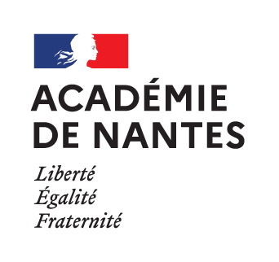

SESSION 2022

BACCALAURÉAT PROFESSIONNEL

ÉPREUVE ORALE SPÉCIFIQUE « SECTION EUROPÉENNE »

ARTISANAT ET MÉTIERS D’ART
OPTION COMMUNICATION VISUELLE PLURIMÉDIA

LANGUE : ANGLAIS

SUJET N°2

Durée de l’épreuve : 40 minutes

- Préparation | - 20 minutes
- Présentation de la situation | - 10 minutes
- Entretien sur les activités et travaux effectués dans la discipline non linguistique | - 10 minutes

SITUATION

You work as a junior art director for the graphic design agency Gray322 based in Dublin.
You are in charge of the creation of a new campaign for Mucinex, a British brand of Reckitt, a pharmaceutical company.
Today, you present your final versions to the senior art director of the agency.
Using the brief, present the different steps leading to your creations and justify your graphic choices.

DOCUMENTS

- N° 1 : THE BRIEF
- N° 2 : FINAL VERSIONS OF YOUR POSTERS FOR MUCINEX

DOCUMENT 1 : THE BRIEF

- Products : 4 posters ;
- Trimmed size : A3 ;
- Bleed : 3 mm ;
- Printing : two colour printing - black + one spot color ;
- Target audience : young adults ;
- General concept :

In the context of a global pandemic, the idea of an awareness campaign initiated by Mucinex is that wearing a mask could help to go back to a normal life faster.
To respond to this message, the graphic design must be as simple as possible and should not use photographs.
It must be evocative of these moments: vacations, spending time with friends, taking care of ourselves… the things we enjoyed doing before the pandemic.
- the texts :
  - four topics, one for each poster – the precise texts must be created : going on vacations, going outside to spend time with friends, going to the hairdresser and going to a party;
  - on all the posters : Back to normal is up to you, Wear a mask ;
- visual elements : the face of a woman or a man wearing a mask. The shape of the mask must be related to the theme of the poster.

DOCUMENT 2 : FINAL VERSIONS OF YOUR POSTERS FOR MUCINEX
Source : www.adsoftheworld.com
