SESSION 2022

BACCALAURÉAT PROFESSIONNEL

ÉPREUVE ORALE SPÉCIFIQUE « SECTION EUROPÉENNE »

SPÉCIALITÉ CONDUCTEUR TRANSPORT ROUTIER MARCHANDISE
CTRM

LANGUE : ANGLAIS

SUJET N°3

Durée de l’épreuve : 40 minutes

- Préparation | - 20 minutes
- Présentation de la situation | - 10 minutes
- Entretien sur les activités et travaux effectués dans la discipline non linguistique | - 10 minutes

SITUATION :

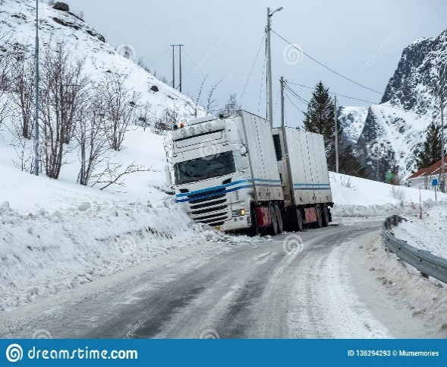
You are a truck driver working for Transalliance situated in Burton on Trent in UK. You are driving to Birmingham to deliver your goods.
It is snowing hard, the road is slippery. Suddenly, you lose control of your vehicle which has overturned and has fallen into the ditch.
The police quickly arrive to take care of the traffic.
Explain how you must react to the situation, the measures you have to take and the people you have to contact.
Then describe the accident to the police, and give as many details as possible : identity, company, goods, location of the accident, problems ...
Finally check if you have all the documents you can be asked to show to the police, if required.

DOCUMENTS :

- N° 1 : A road accident
- N° 2 : Information about your company
- N° 3 : Documents needed

DOCUMENT 1 : A ROAD ACCIDENT

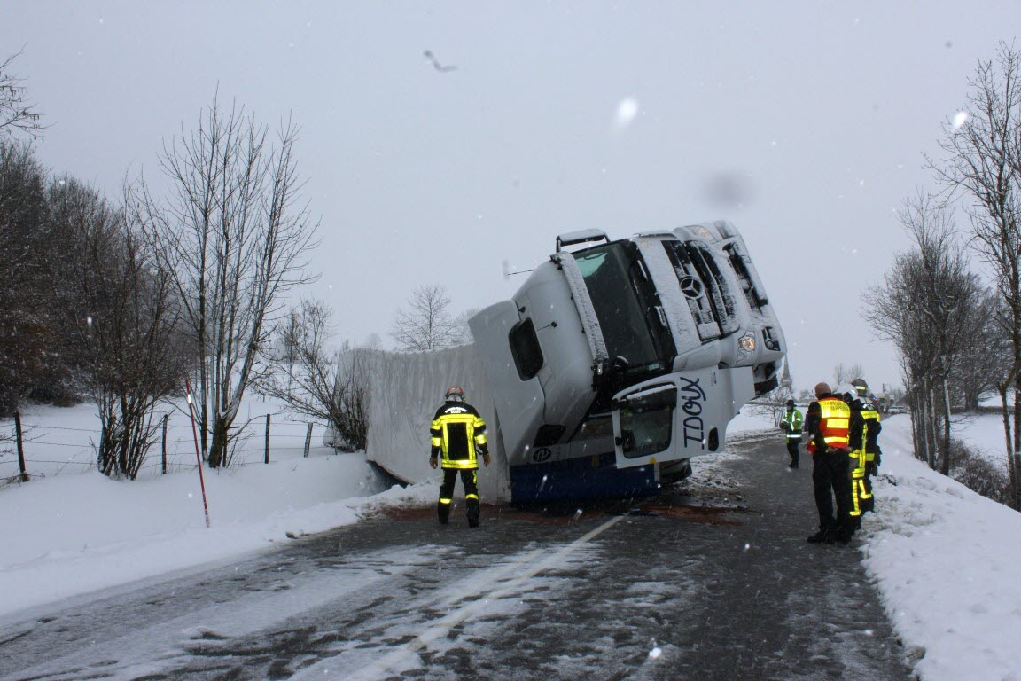

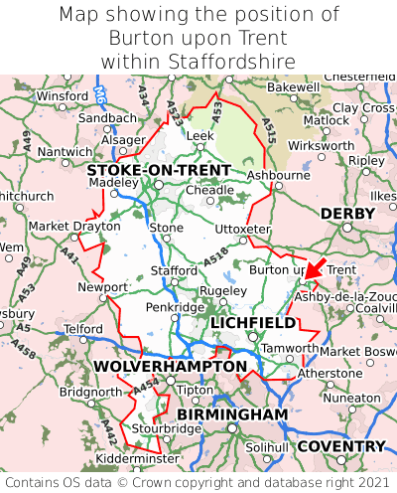
Burton on Trent
A 454
Birmingham
A5

Source : https://www.google.com/search?
DOCUMENT 2 : INFORMATION ABOUT YOUR COMPANY
- Name : Transalliance UK
- Transalliance TS Limited's headquarters : Suite 8-9 Faraday Court Centrum One Hundred Burton-on-Trent, DE14 2WX United Kingdom
- Transalliance TS Limited's key principal : Peter John Ellison Coley
- Transalliance TS Limited's phone number : +44-1283735100
- Type of transport : road and multimodal transport (train, boat, plane)
- Types of goods : bulk, general goods, fresh and frozen food, liquids
- Clients : UK, Europe, International
- Sustainable company : environmentally friendly waste management at the logistics sites + 3-year action plan to cut CO2 emissions

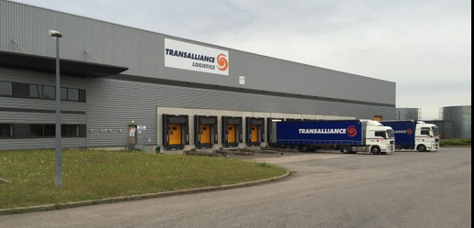

Source : https://www.transalliance.eu/en/transport

DOCUMENT 3 : DOCUMENTS NEEDED

GOODS

DRIVER

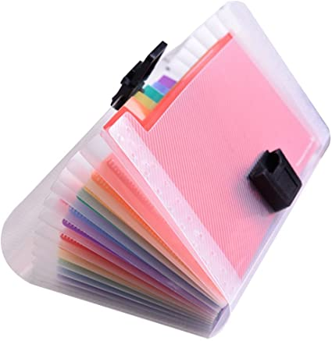
TRUCK

Source : https://www.google.com/search?

