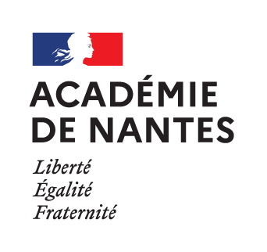

SESSION 2022

BACCALAURÉAT PROFESSIONNEL

ÉPREUVE ORALE SPÉCIFIQUE « SECTION EUROPÉENNE »

ARTISANAT ET MÉTIERS D’ART
OPTION COMMUNICATION VISUELLE PLURIMÉDIA

LANGUE : ANGLAIS

SUJET N°3

Durée de l’épreuve : 40 minutes

- Préparation | - 20 minutes
- Présentation de la situation | - 10 minutes
- Entretien sur les activités et travaux effectués dans la discipline non linguistique | - 10 minutes

SITUATION

You work as a junior art director for the graphic design agency Gray322 based in Dublin. You are in charge of the creation of a new front cover for a special edition of Charles Dickens’ A Christmas Carol.
Today, you present your layouts to the senior art director of the agency :
- Present and justify your graphic choices according to the brief.
- Tell which cover you prefer and justify your choice.

DOCUMENTS

- N° 1 : THE BRIEF
- N° 2 : LAYOUTS

DOCUMENT 1 : THE BRIEF

- Client: Penguin Random House Company ;
- Book: A Christmas Carol ;
- Collection: Puffin classics ;
- Trimmed size: 105 x 155 mm ;
- Untrimmed size: 111 x 161 mm ;
- Bleed: 3 mm ;
- Printing: four colour process ;
- Target audience: children ;
- General concept: it should be representative of the spirit of Christmas, carry an atmosphere of magic and mystery ;
- The front cover: it must mainly work on the illustration and fonts.
- The texts: Charles Dickens, A Christmas Carol ;
- Visual elements: the illustration must be simple and mostly rely on Christmas patterns. The less colours you’ll use, the better it will be. The general atmosphere must be dark, but not scary. The story is about ghosts and the supernatural world but it’s not terrifying. The story ends well and is about the meaning of life, the way to happiness.

DOCUMENT 2 : LAYOUTS

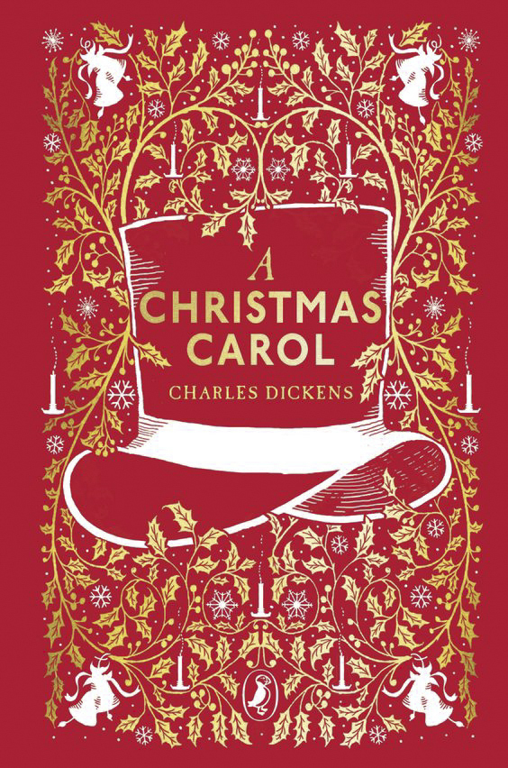
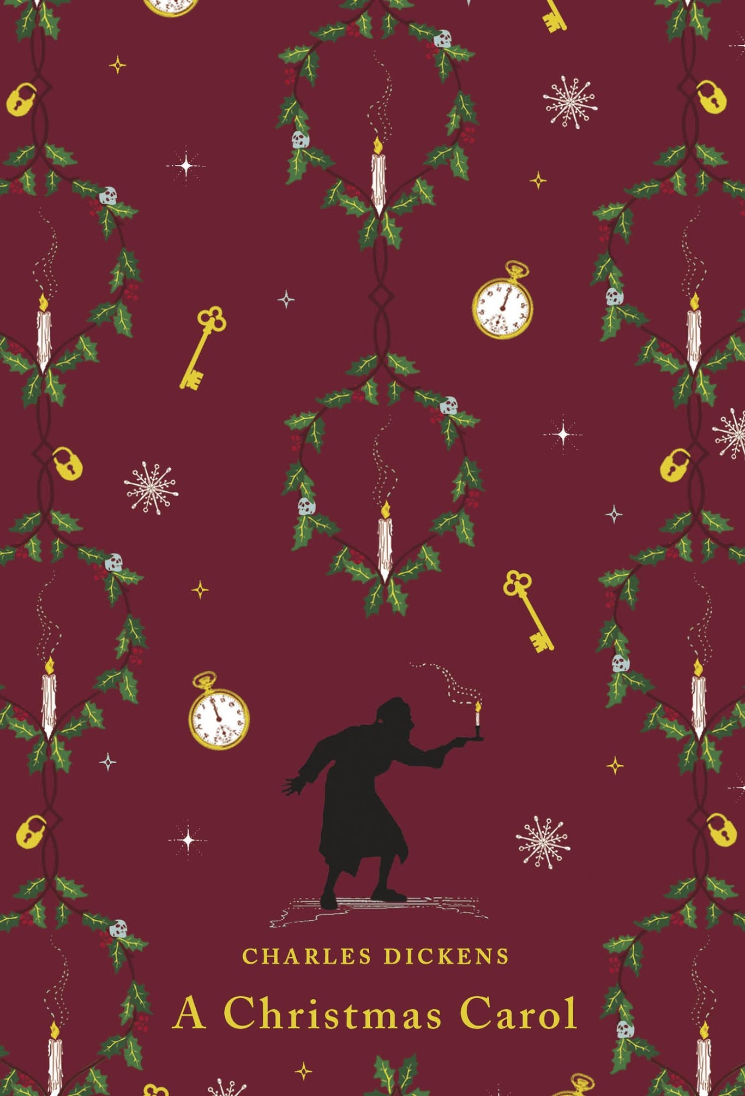
Sources : https://www.penguin.co.uk, https://www.penguin.com.au

