Enseignement technologique en langue étrangère | STL
Activité 03 Determination of pH.

Determine pH with pH indicator strips and universal indicator solutions.
Here is a video about the determination of pH. Let’s take a look at it and let’s try to understand the main points.
http://www.youtube.com/watch?feature=player_embedded&v=PLad5Wm-gC8
- Watch the video.
- Listen and isolate the words used in the following sentences:
The pH of a solution is ………………………. as the negative logarithm of its hydrogen ion …………………………………… in gram/moles per liter. It helps to point out……………………………the given substance is acidic, alkaline or ……………………………. PH is measured on a …………………….of 0 to 14. The pH of a neutral solution is 7, acidic solution is less than 7 and alkaline solution is greater than 7. The pH value of a solution can be determined using a pH paper or universal indicator solution that have……………………………….of indicators exhibiting several smooth color changes over a very …………………………… range of pH values.
Our …………………………. here is to find the pH of given samples using pH paper and universal indicator solutions.
Procedure
Take a strip of pH paper and place it on the tile. Take a ………………………..of common salt solution from the ………………………… using a dropper and ………………………..it over the pH paper placed on the tile. Observe the color produced and compare it with the different color ………………………. of the standard color pH chart and ……………………………. the pH value. Using a fresh dropper, take one drop of universal indicator solution and ………………………..into the common salt solution ………………………. in the beaker. Observe the color produced and compare it with different color shades of the indicators given on the universal indicator ……………………..and again find out the pH value of the solution. You can observe that in ……………………..the tests the pH value of common salt is 7. Repeat the same …………………….for finding the pH value of sodium bicarbonate solution and 0.1 molar HCl using fresh strips of pH paper, universal indicator and …………………………… fine droppers for every sample. Through these methods, we can determine the pH value of 0.1 molar HCl and pH value of sodium bicarbonate. The pH value of 0.1 molar HCl is 1 and that of sodium bicarbonate is 9.

Precautions
If you are using the same dropper for the tests of all samples, ensure that it has been ……………………….washed with water after every test. Make sure that the pH strips are kept away from ………………………………………….

Materials required:
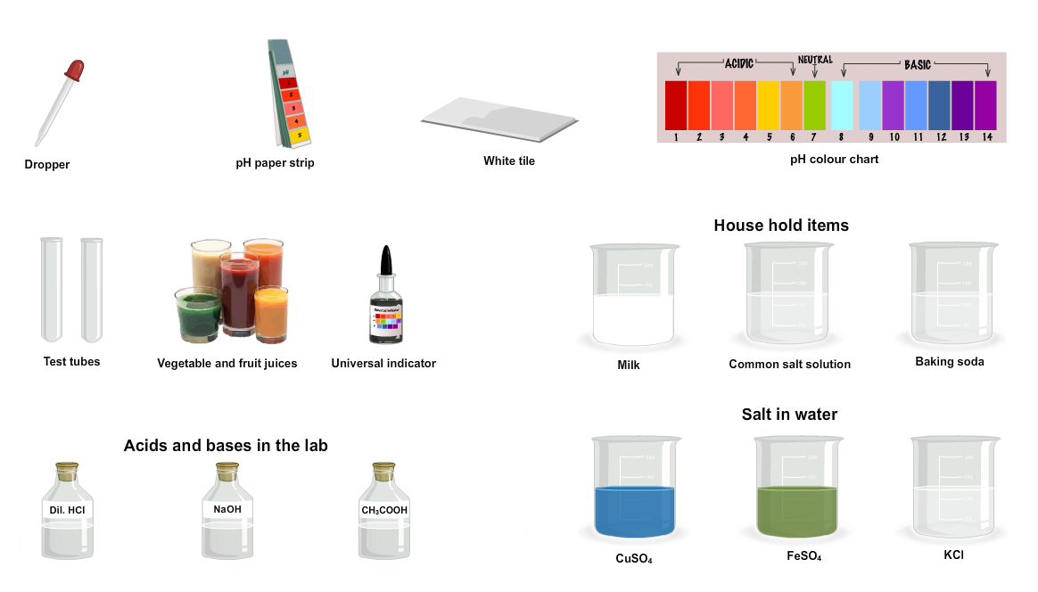

- Write down the main steps of the process of the determination of pH: verbs and nouns and present them to the class.

Source: http://www.amrita.edu/

Experiment 01.
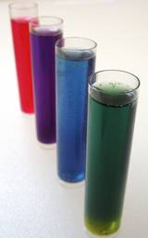
You want to determine the pH of a solution among those laid out on the professor desk: solution A, B or C in three test tubes.
To do this, you have got four universal indicator solutions: bromophenol blue, methyl red, helianthin and cresol red.
- Prepare your presentation for the class.

MethylRed
below pH 4.4 |  | above pH 6.2
4.4  RED | ORANGE  ↔ | 6.2  YELLOW

Bromophenol blue
below pH 3.0 |  | above pH 4.6
3.0  YELLOW | GREEN  ↔ | 4.6  BLUE

Helianthin
below pH 3.1 |  | above pH 4.4
3.1  RED | ORANGE  ↔ | 4.4  YELLOW

Cresol Red
below pH 7.2 |  | above pH 8.8
7.2  YELLOW | ORANGE  ↔ | 8.8  RED

- With the help of Xmind, build a mind map to sum up your results.

Experiment 02.
There are many common household products and garden plants that can be used as pH indicators. Most plants contain pH sensitive anthocyanins. Many of these natural pH indicators exhibit a broad range of colors.
For example, red cabbage juice can be used to test the pH of common household chemicals. From left to right, the colors result from lemon juice, natural red cabbage juice, ammonia, and laundry detergent.
Source: http://chemistry.about.com/cs/acidsandbases/a/aa060703a.htm
- By adding hydrochloric acid and (or) sodium hydroxide, find the different colors of the natural pH indicator, red cabbage juice.

Test tubes | 01 | 02 | Control tube 03 | 04 | 05
Hydrochloric acid (drops) |  |  | 0
Sodium hydroxide (drops) |  |  | 0
Color of red cabbage juice
pH

Application.
- You want to determine the pH of a solution among those laid out on the professor’s desk: solution A, B or C. To do this, you have the red cabbage juice. Prepare your presentation for the class.
Improving your pronounciation: how to make a cabbage pH indicator.
http://video.about.com/chemistry/Cabbage-pH-Indicator.htm
“All you need for this project are a couple of leafs from a red or purple cabbage and a coffee filter.
Tear the cabbage leafs into small pieces and set them onto a microwave safe plate.Microwave the cabbage for a fewminutes until the leafsare softly cooked and allow the cabbage to cool. Then press the coffee filter into the leafs to absorb the colored cabbage juice. When the coffee filter has been completely saturated with juice, set it to the side and allow it to dry. The colored coffee filter is your pH paper but it will be easier to work with if you cut it into several smaller pH paper test strips. Drip the chemical you wish to test onto one of these strips. The color change of the pH paper indicates the pH or acidity of a chemical.To be an acid or a base, the chemical needs to contain some water. So certain chemicalssuch as vegetable oil will not change the color of your pH paper test strip.Can you predict which chemicals are acids or bases ?”

DATE : |  | STL DNL
HEURE : | SALLE : | POSTES : 01

Determination of pH-experiment 01

Matériel prof
- Dans 3 béchers 100 mL : solutions tampon pH 4, 7 et 10 (50 mL) ;
- 20 tubes à essai sur trois supports ;
- Pipettes plastiques (10) ;
- Indicateurs colorés :
- Bleu de bromophénol ;
- Rouge de crésol ; ;
- Helianthine ;
- Rouge de methyle ;

Bidons

DATE : |  | STL DNL
HEURE : | SALLE : | POSTES : 01

Determination of pH-experiment 02

Matériel prof
- Dans 1 bécher, 250 mL de jus de chou rouge ;
- 5 béchers 50 mL ;
- Pipettes plastiques : 15 ;
- HCl 10⁻¹ mol/L : 50 mL ;
- NaOH 10⁻¹ : 50 mL ;
- 20 tubes à essais sur 3 supports ;
- 1 bécher 100 mL : tampon 7 incolore ;
- 1 bécher 100 mL : tampon 9 incolore ;
- Deux paires de lunettes et 2 blouses ;
- Papier absorbant ;

Bidons

