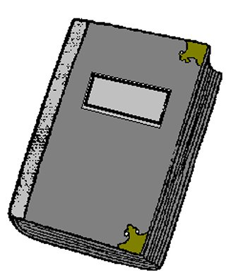 | 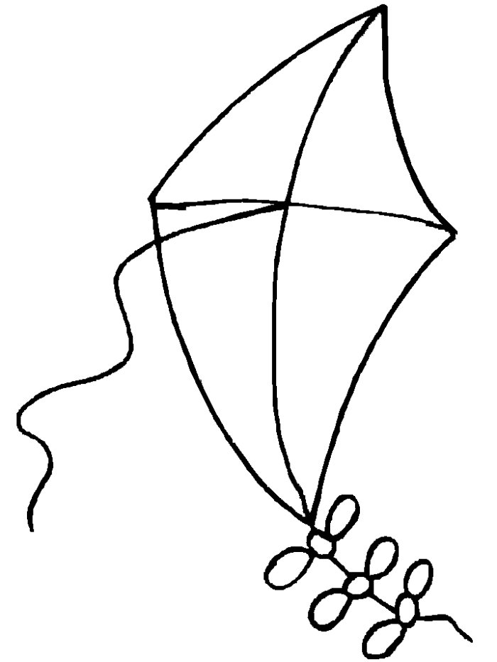 | 
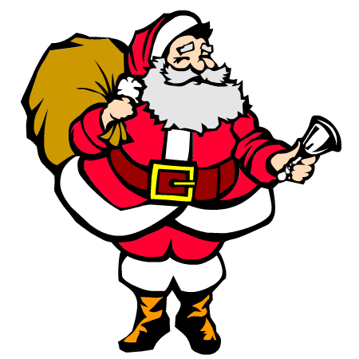 | 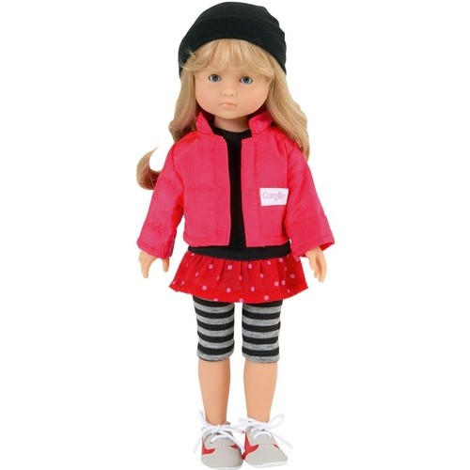 | 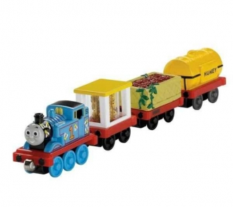

Father Christmas | a doll | a kite
a book | a ball | a train

Dear …………………………
How are you ?
For Christmas, I want …………………….. , …………......,
and …………………………… .
Thank you.
I wish you a merry …………………….. .

Christmas | a book | a kite
Father Christmas | a ball

