SESSION 2022

BACCALAURÉAT PROFESSIONNEL

ÉPREUVE ORALE SPÉCIFIQUE « SECTION EUROPÉENNE »

SPÉCIALITÉ : ÉTUDE et RÉALISATION d’AGENCEMENT

LANGUE : ANGLAIS

SUJET N°1

Durée de l’épreuve : 40 minutes

- Préparation | - 20 minutes
- Présentation de la situation | - 10 minutes
- Entretien sur les activités et travaux effectués dans la discipline non linguistique | - 10 minutes

SITUATION :

You work as a technician at LDN furniture Company and you are in charge of welcoming a new temporary woodworker in your company.
The person comes to reinforce the team to produce a dressing room.
Explain to him the safety rules in the wood workshop business and the project of the dressing room he has to work on : how the room will be organized, the materials used, the joining system and more...
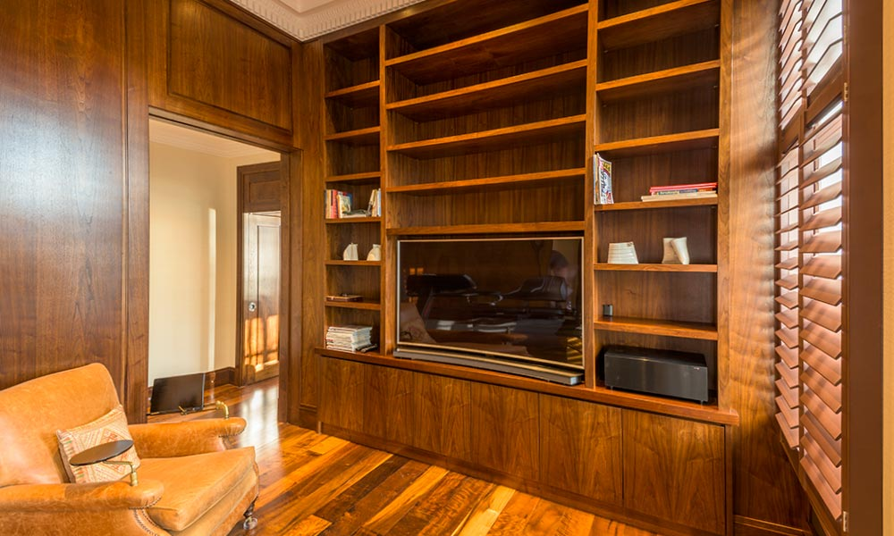
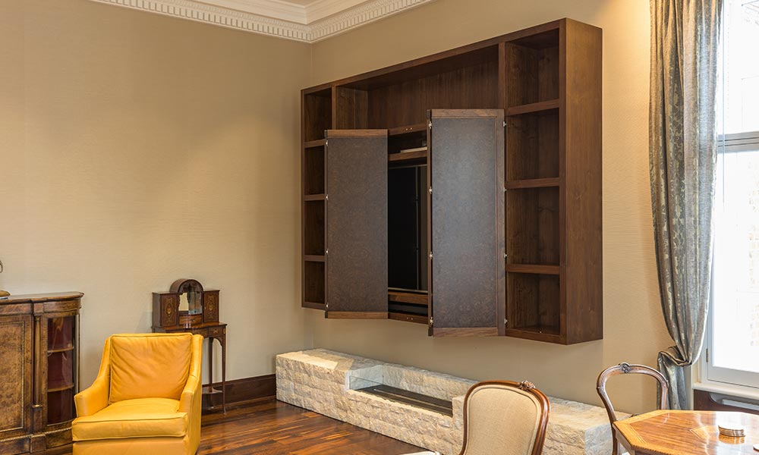

DOCUMENTS :

- N° 1 : SAFETY RULES IN THE WORKSHOP
- N° 2 : PLANS OF THE DRESSING ROOM

DOCUMENT 1 : SAFETY RULES IN THE WORKSHOP

What safety procedures should you follow when using woodworking machines?
- Always wear safety glasses or goggles, or a face shield (with safety glasses or goggles).
- Wear hearing protection that is suitable for the level and frequency of the noise you are exposed to in the woodworking area.
- Use gloves to protect hands from splinters when handling wood but do not wear them near rotating blades and other machinery parts where the gloves can catch.
- Wear protective footwear.
- Make sure the guard is in position, is in good working condition, and guards the machine adequately before operating any equipment or machine. Check and adjust all other safety devices.
- Make sure the equipment is properly grounded before use.
- Check that keys and adjusting wrenches are removed from the machine before turning on the power.
- Inspect stock for nails or other materials before cutting, planning, routing or carrying out similar activities.
- Make sure that all machines have start and stop buttons.
- Turn the power off and unplug the power cord (or lock out the power source) before inspecting, changing, cleaning, adjusting or repairing a blade or a machine. Also turn the power off when discussing the work.
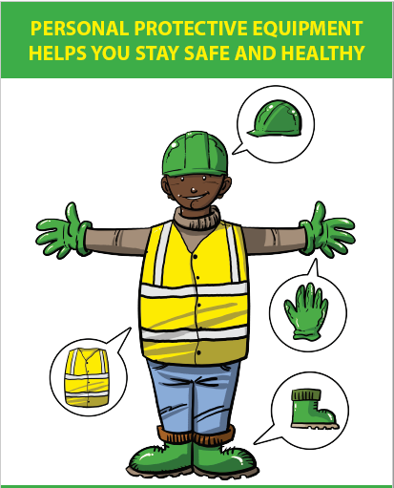
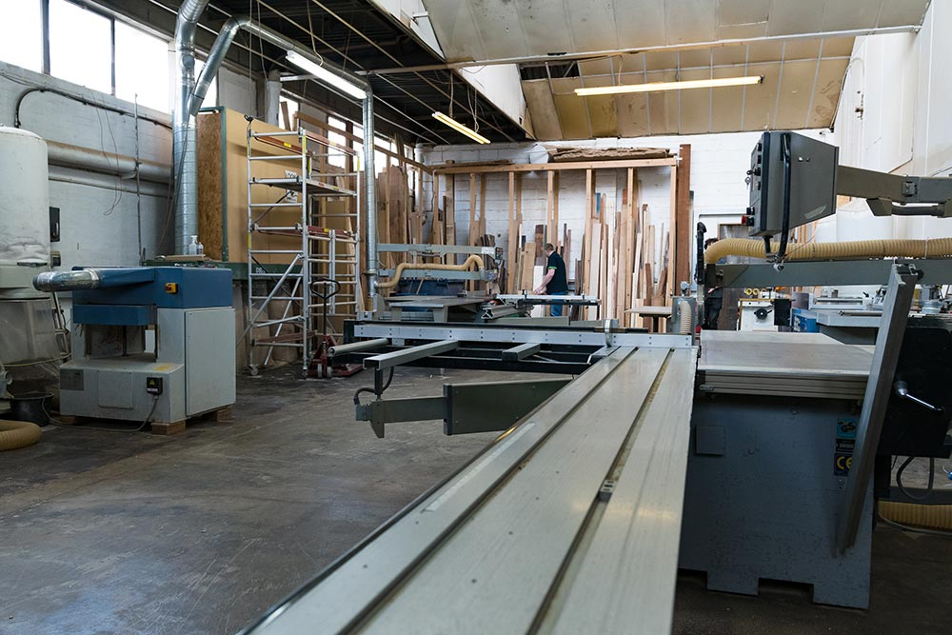
http://ccohs.ca/oshanswers/safety_haz/woodwork/gen_safe.html

DOCUMENT 2 : PLANS OF THE DRESSING ROOM
https://lamco-design.co.uk/case-studies/lamco-dressing-room/
