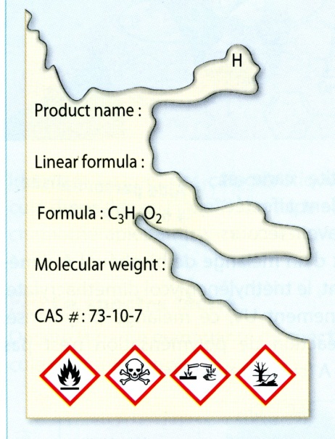
Uncompleted label.
Doc.1: Fragment of a label on a bottle containing an unknown chemical species.
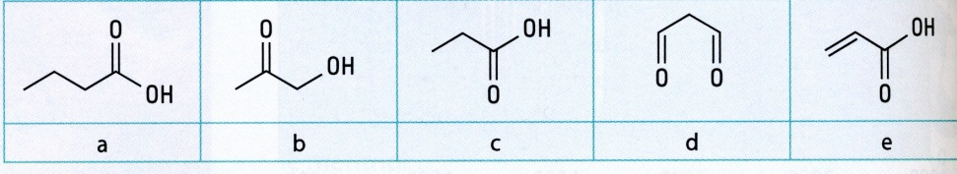
Doc.2: Chemical species on the stock list in the laboratory.

Doc.3: Infra-red spectrum of the liquid contained in the bottle. Doc.1
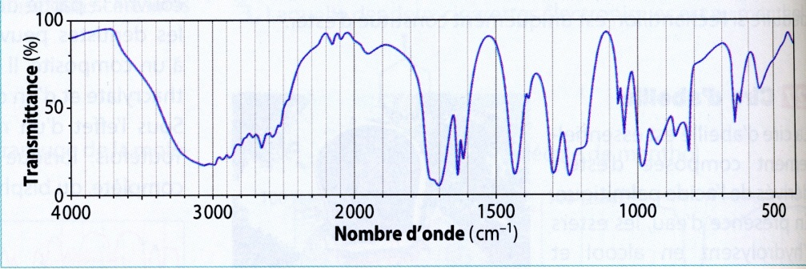

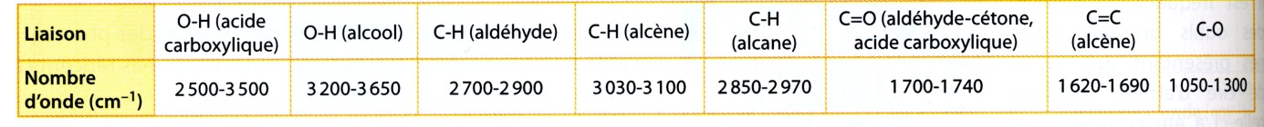
Doc.4: matching wavenumbers with bonds.
Questions:
- Write the structural formula of the molecules given on the stock list of the lab.
- Circle the functional groups and name them.
- Name the molecules a) and c).
- Can you recognize isomers over the five molecules? Which ones? Justify your answers.
- One of the molecules can be eliminated without the help of the IR spectrum. Which one? Why?
- Which quantity is represented on the vertical axis of the spectrum? What does it correspond to?
- Which quantity is represented on the horizontal axis of the spectrum? What does it correspond to?
- Which characteristic peaks does the IR spectrum of the chemical species analysed present? Describe them using the following vocabulary: thin, large, weak, medium, intense.
- Which bonds can you identify thanks to these peaks? Two other molecules can be eliminated, which ones? Why?
- Which information does the peak around 1600 cm⁻¹ give us?
- Identify the chemical species in the bottle? Justify your answer.
- What does the part of the spectrum between 1500 and 400 cm⁻¹ represent?
- Complete the label.
- Give the signification of the pictograms.

Data : molar atomic masses in g.mol⁻¹ M(H) = 1.0 ; M(C) = 12.0 ; M(O) = 16.0

