ROSSO COME IL CIELO (1)

Regista :
Anno :


_______________________________________________________________________________________________________________________________________________________________________________________________________________________________________________________________________________________________________________________________________________
TRAMA :

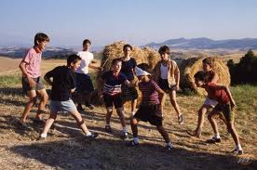
____________________________________________________________________________________________________________________________________________________________________________________________________________

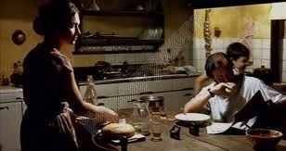
________________________________________________________________________________________________________________________________________________________________________________________________

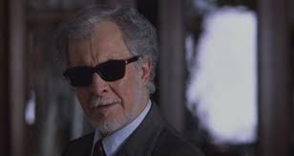
____________________________________________________________________________________________________________________________________________________________________________________________________________________

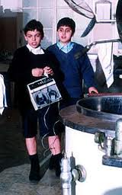

____________________________________________________________________________________________________________________________________________________________________________________________________________________________________________
___________________________________________________________
ROSSO COME IL CIELO (2)




