
How to use a fluid to warm or cool?
Heat pump.

I Key words (individual work)

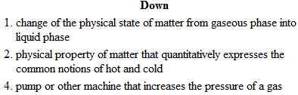
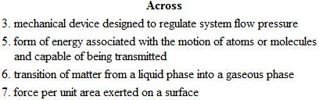


II Basic experiments (presentation by pupils)

Available equipment:

- syringe with flexible pipe - test tube - cloth
- pressure meter - flask of ether - mobile extractor fan
- water - electronic thermometer - gloves and glasses

→ 1) Demonstrate that the change of state temperature depends on the pressure.
Explain what you need, describe what happens and conclude.

→ 2) Highlight the fact that a change of state can involve a heat consumption.
Explain what you need, describe what happens and conclude.

 | What happens | Conclusion
Experiment 1
Experiment 2

III Operating principle of a heat pump (individual work)

Its principal plan is represented below:
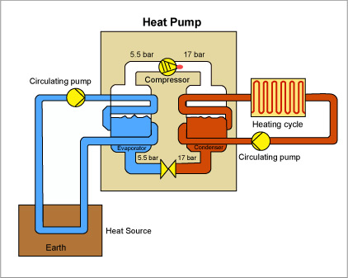
1) What happens to the fluid in the evaporator?

2) Why is a compressor needed?

3) What about the condensor?

4) Compare the electrical energy required to operate the compressor and the energy produced as heat. What is the point?

IV Professional simulation (presentation by pupils)

You work in a company that offers marketing and installation of heat pumps.

As a project manager, you need to promote this type of heating presenting its advantages over more common and less efficient methods of heating, from the point of view of energy.

Your audience will appreciate a slideshow that will allow you to briefly explain the principle and the strengths of your products.

Make a slideshow (10 pages maximum) with your usual tools. It may be decorated with photos, figures and comparative studies

I Key words (individual work)

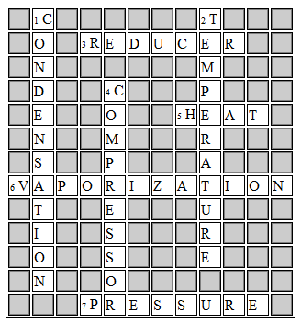

II Basic experiments (presentation by 2 pupils)

 | What happens | Conclusion
Experiment 1 | We introduce a bit of warm water in a  syringe. The syringe is obstructed with a  finger tip. Gradually pulling the plunger,  we find that water boils | It is possible to cause the change of state  of a fluid acting on the pressure value.
Experiment 2 | Under the hood: pouring water in a test  tube covered with a cloth. An electronic thermometer indicates the temperature  of the water. Soak the cloth with ether.  Quickly, the water temperature decreases  Finally, the cloth is dry. | When fluid passes from the liquid state to  the gaseous state, it takes heat from the surrounding environment.

III Operating principle of a heat pump (individual work)

1) the fluid passes from the liquid state to the gaseous state and draws energy (heat) from the ground

2) the compressor increases the gas pressure and its temperature

3) in the condenser, the fluid passes from the gaseous to the liquid state, which allows providing heat for heating

4) the electrical energy required to operate the pump is lower than that produced in the form of heat.

IV Professional simulation: example of video

http://www.youtube.com/watch?v=g39nM7GbSJA

