How to comment a scientific document?
- Introduction.
- What is it about?
- Where does it come from?
- What is it composed of?

- Explain the scientific content of the document.
- Describe the experiments, the apparatus, the diagrams, the graphs …
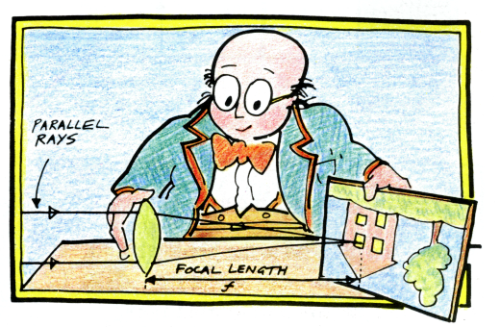
- Explain the main scientific ideas.

- Conclusion.
Give your opinion about the document and the subject it deals with.

From : Physics for you (Keith Johnson)

