Let’s celebrate Ireland !
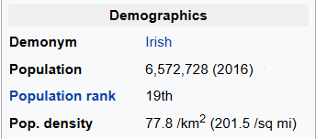
Exercise 1 : a few country facts. (season 1)
You can read these numbers on the Wikipedia page about Ireland.
- What is the area of Ireland ?
- An accurate calculation of the population density gives 77,8565 inhab/km². What is the real area of Ireland ?
- Explain why the difference between the two values is actually negligible.
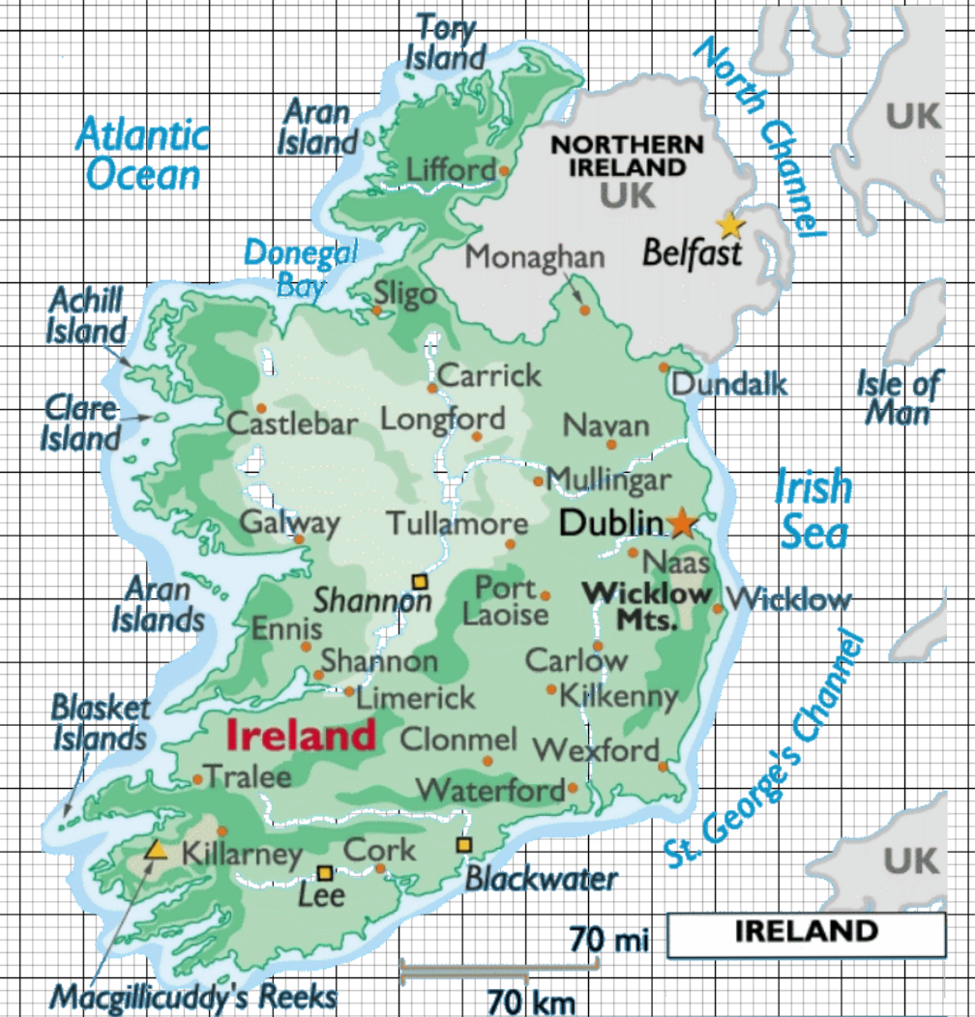
Exercise 2 : a few country facts. (season 2)
- Calculate the straight-line distances from : / Calculate the distances as the crow flies from :
- Dublin to Galway
- Cork to Limerick
- Kilkenny to Waterford

- Use the map on the right to calculate an estimate of Ireland’s area.

Exercise 3 : a few country facts. (season 3)
- Check the population of these five cities are equivalent to about 14 % (= per cent) of the population of Ireland.  - Let’s take a closer look at the four most populated cities, except for Dublin. They will be referred to as CLGW.  Check the population ratio of Dublin to CLGW is about 11:7. | The main cities in 2016 were :  Dublin : 553 165 inhabitants  Cork : 125 622 inhabitants  Limerick : 94 192 inhabitants  Galway : 79 934 inhabitants  Waterford : 45 748 inhabitants

