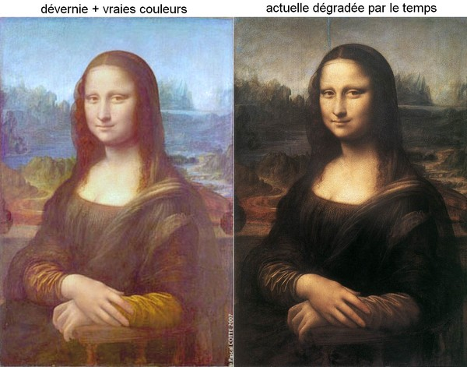
- Introduction.
Analytical chemistry plays a significant role in today’s society. It is used in forensic, art, medical and industrial laboratories and helps us monitor our environment and check the quality of food we eat and the materials we use.
Early analysts relied on their senses to discover the identity of unknown substances, but they now have the ability to probe the structure of substances using electromagnetic radiation beyond the visible region.
This has allowed us to discover how atoms are bonded in different molecules, and to detect minute quantities of substances in mixtures down the levels of parts per billion.
A battery of tools and range of skills have been developed. Many of the methods are automated, involving computers and robotics.
- Analytical techniques.
Chemical analysts identify and characterize unknown substances, determine the composition of a mixture and identify impurities. Their work can be divided into:
- Qualitative analysis: the detection of the presence but not the quantity of a substance in a mixture, for example, forbidden substances in an athlete’s blood.
- Quantitative analysis: the measurement of the quantity of a particular substance in a mixture, for example, the alcohol levels in a driver’s breath, or the toxic metal levels in a sample of river water.
- Structural analysis: a description of how atoms are arranged in molecular structures, for example, the determination of the structure of a naturally occurring or artificial product.
Many instruments are available to provide structural analysis but they generally work by analysing the effect of different forms of energy on the substance analysed.
This year you will study two of these techniques:
- Infrared spectroscopy which is used to identify the bonds in a molecule.
- Nuclear magnetic resonance spectroscopy which is used to show the chemical environment of certain atoms (hydrogen, carbon, phosphorus and fluorine) in a molecule and so gives vital structural information.

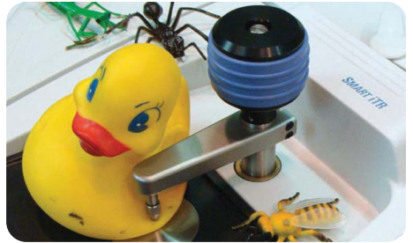
Example 1: To check whether a plastic toy contains phthalate plasticizers, the toy is placed on the IR accessory and pressed down on the optical crystal using the pressure controller to obtain a spectrum for analysis.
From: Advanced materials and processes. April 2010.

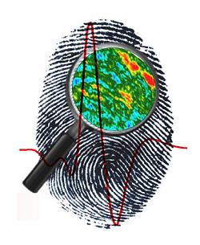
Example 2: Forensic scientists have used infrared spectroscopy for some time to investigate paint samples from crime scenes. Now the technique is being used in fingerprint analysis. If fingerprints are found at a crime scene, they are carefully lifted from a surface using gelatin tape. This special type of tape is used because gelatin does not interfere with the chemical composition of the fingerprint and affect the analysis. Chemical photography can then be used to differentiate the chemical content of the fingerprint. The chemical makeup of the fingerprint can then be matched to samples taken from suspects.

http://invigorate.royalsociety.org
Example 3: A near infrared (NIR) imaging spectrometer was used for the study of an early 15th century illuminated manuscript leaf on parchment painted by Lorenzo Monaco and representing a Praying Prophet within a decorated initial E on a gilded background (pictured).
Art historians and conservationists need detailed information about materials used by artists, such as the pigments and the organic binding agents, for example gum Arabic or egg white, which were used to carry the pigment.
http://www.chemistryviews.org
- Principles of spectroscopy.
The electromagnetic spectrum
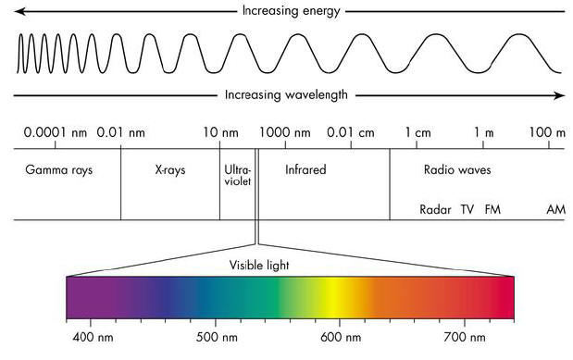

http://9-4fordham.wikispaces.com
As discussed in the previous years, electromagnetic radiation is a form of energy transferred by waves and characterized by its:
- Wavelength (λ) : the distance between two successive crests or troughs (in m)
- Frenquency (ν): the number of waves which pass a point every second (in Hz)
The energy of electromagnetic radiation is carried in packets of energy called photons or quanta. The energy of the radiation is related to the frequency by Planck’s equation: E = h.ν ; where h is Planck’s constant (6.63 x 10⁻³⁴ J.s).
The wavelength and frequency are related by the equation: c = λ.ν where c is the speed of the wave (here c is the cosmic speed limit : 3.00 x 10⁸ m.s⁻¹ as according to Einstein’s theory of Relativity, nothing in the universe can travel faster than this).
Worked examples:
- Calculate the energy of a photon of visible light with a frequency of 3.0 x 10¹⁴ Hz. Express your answer in kJ.mol⁻¹.
- A beam of IR radiation has energy of 4.00 x 10⁻²⁰ J per photon. Calculate the frequency of the radiation.

4. Absorption and emission spectra.
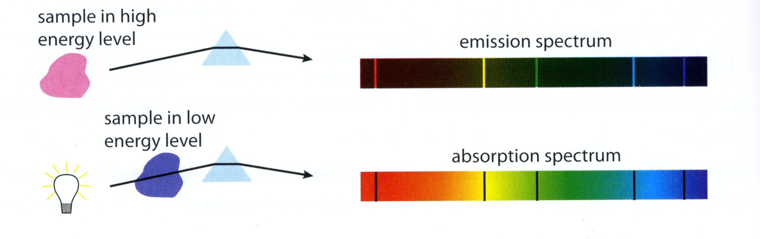

- An emission spectrum is produced when a molecule moves from a higher to a lower energy level.
- An absorption spectrum shows the radiation absorbed as atoms or molecules move from a lower to a higher energy level.
- Each element produces its own distinctive spectrum which can be used as a “fingerprint” to identify the element.
5. Infrared (IR) spectroscopy.
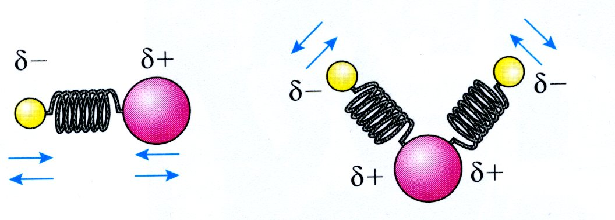

A chemical bond can be thought as a spring. Each bond vibrates and bends at a natural frequency which depends on the bond strength and the masses of the atoms. Light atoms can vibrate at higher frequencies than heavier atoms and multiple bonds vibrate at higher frequencies than single bonds.
The energy needed to excite the bonds in a molecule to make them vibrate with greater amplitude, occurs in the IR region.
IR radiation can cause a bond to stretch or bend.
In IR spectroscopy, the frequency of radiation is often measured as number of waves per centimeter (cm⁻¹), also called the wavenumber.

6. Nomenclature of organic compounds.
Rule 1: identify the longest strain or continuous chain of carbon atoms; this gives the stem of the name as follows.
Number of carbon atoms in the longest chain | stem
1 | Meth-
2 | Eth-
3 | Prop-
4 | But-
5 | Pent-
6 | Hex-
7 | Hept-
8 | Oct-
9 | Non-
10 | Dec-

Rule 2: use the functional group ending as the last part or suffix of the name. They are summarized in the table below.
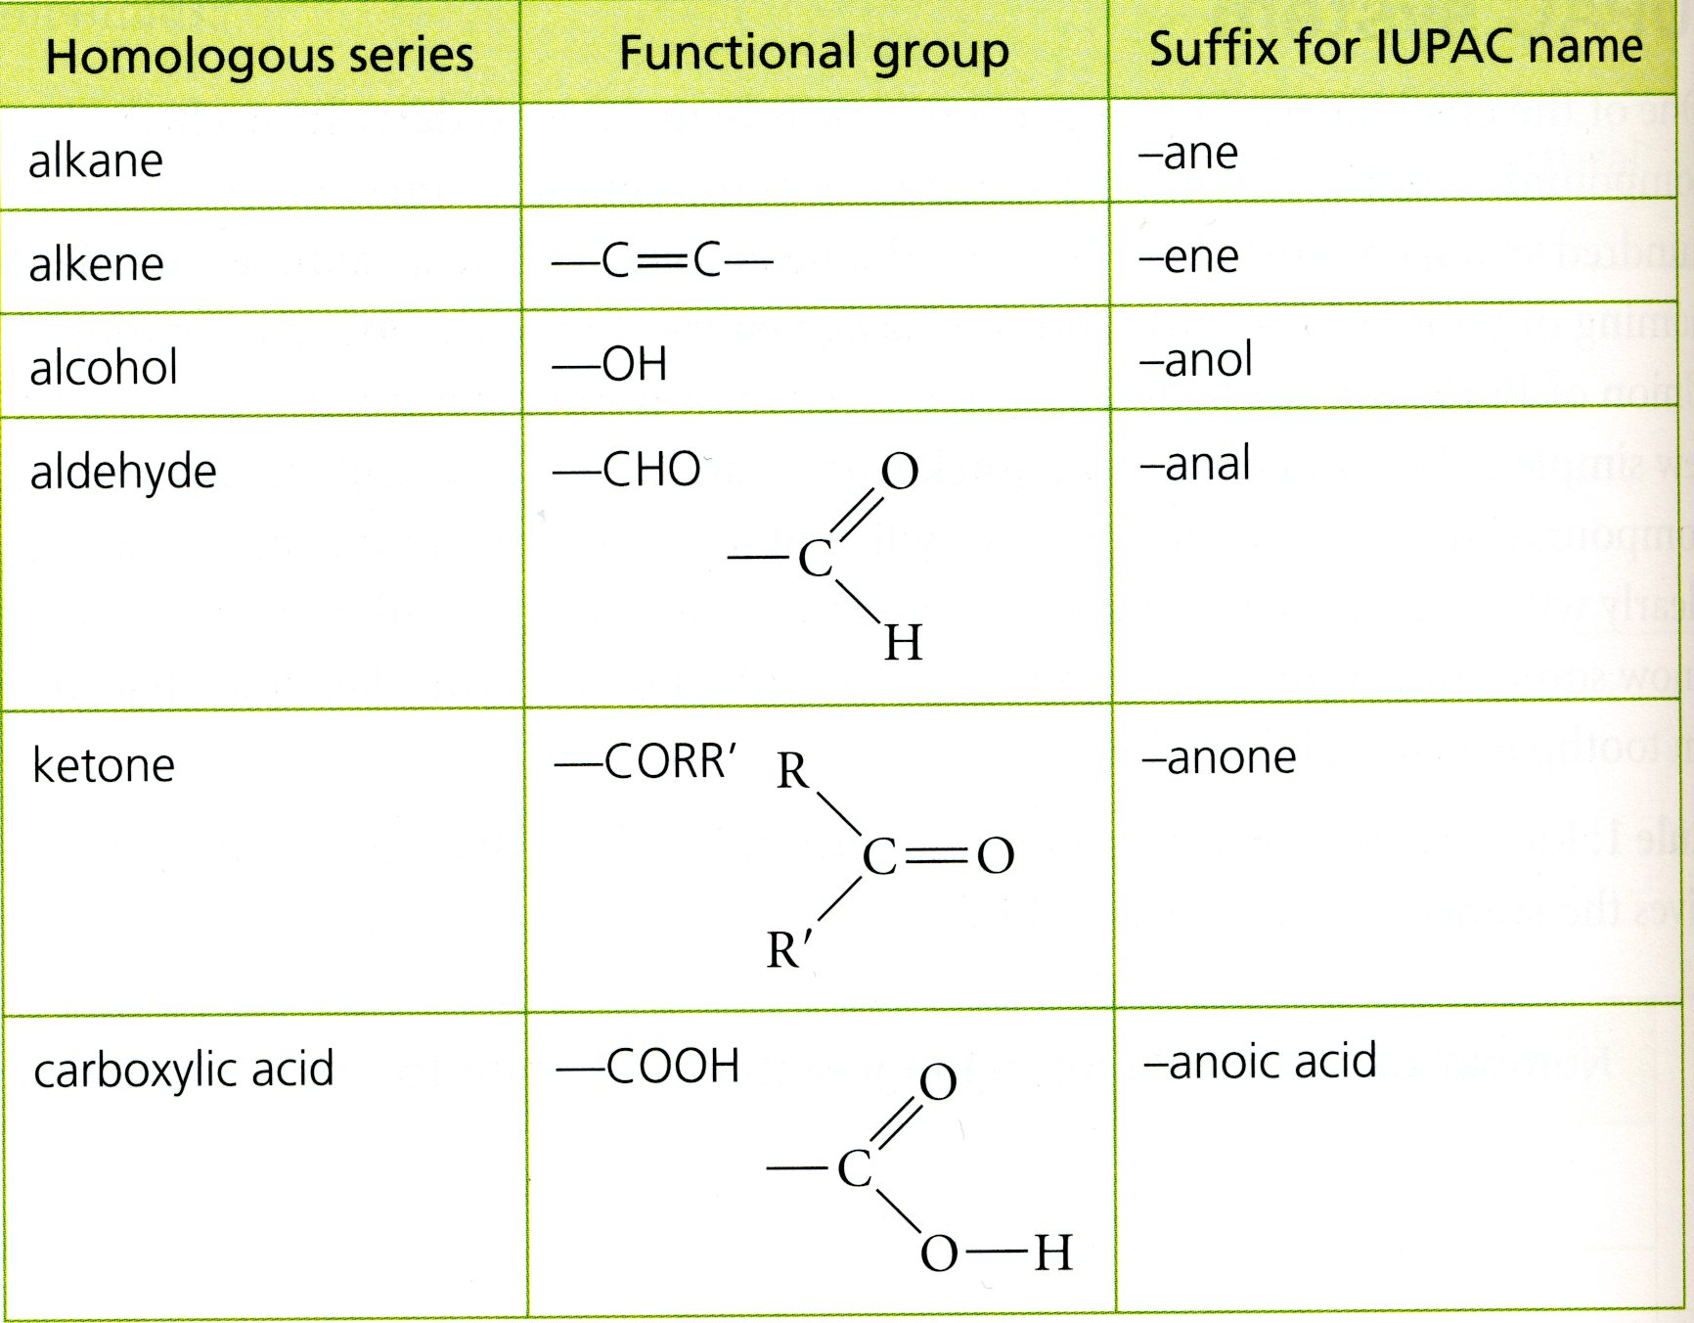

Rule 3: Name the side groups or substituent groups as the first part or prefix of the name. The common ones are summarized below.
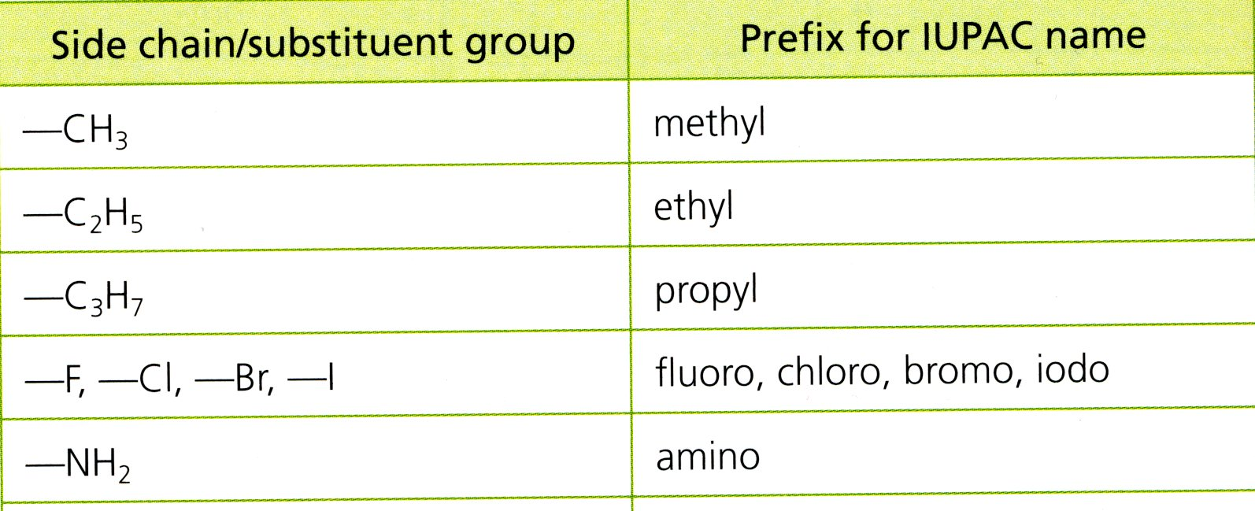

The position of these substituent groups is shown by a number, followed by a dash, which refers to the number of the carbon atom to which it is attached. The carbon chain is numbered starting at the end which will give the substituent groups the smallest number.
Ester functional group:
Esters are organic compounds which form when organic acids react with alcohols.
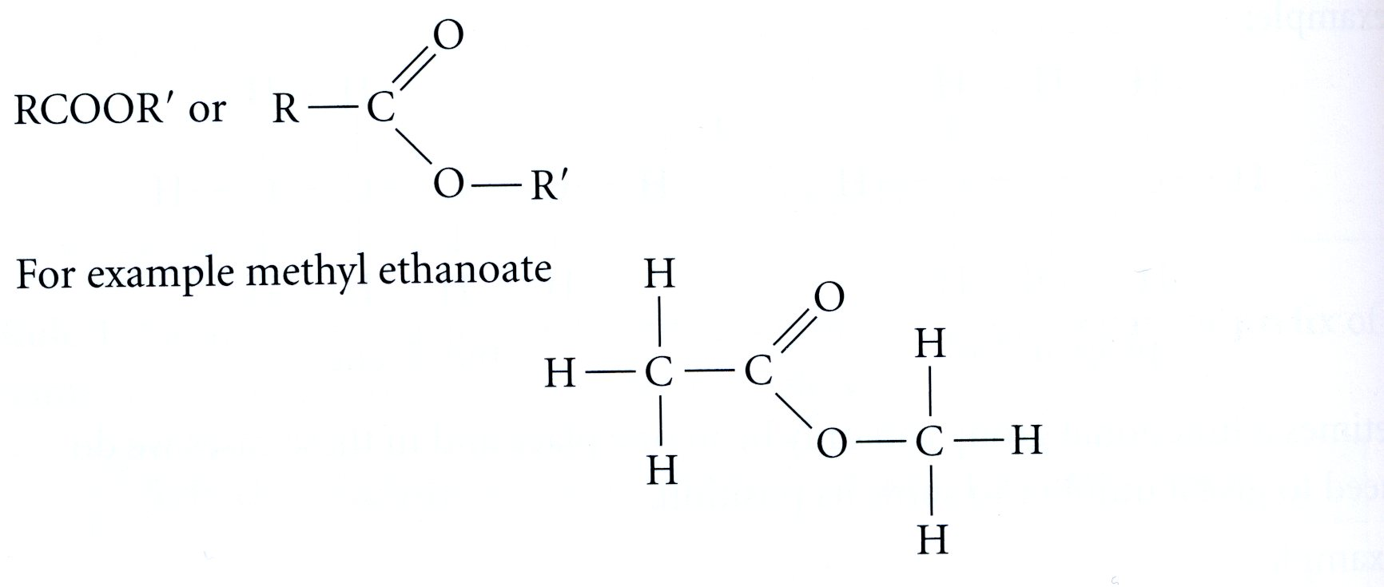
Their functional group is:

The methyl ethanoate contains the methyl group from the alcohol methanol and the ethanoate derived from ethanoic acid.

Worked examples:

7. Matching wavenumbers with bonds.
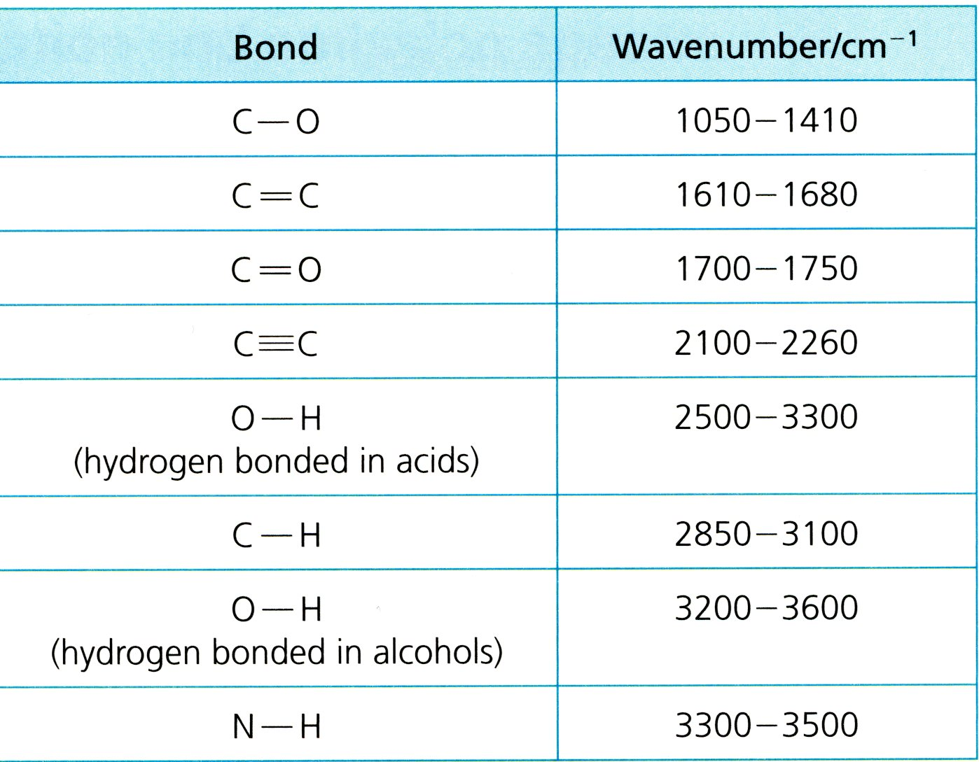
The absorption of particular wavenumbers of IR radiation helps the chemist to identify the bonds in a molecule.

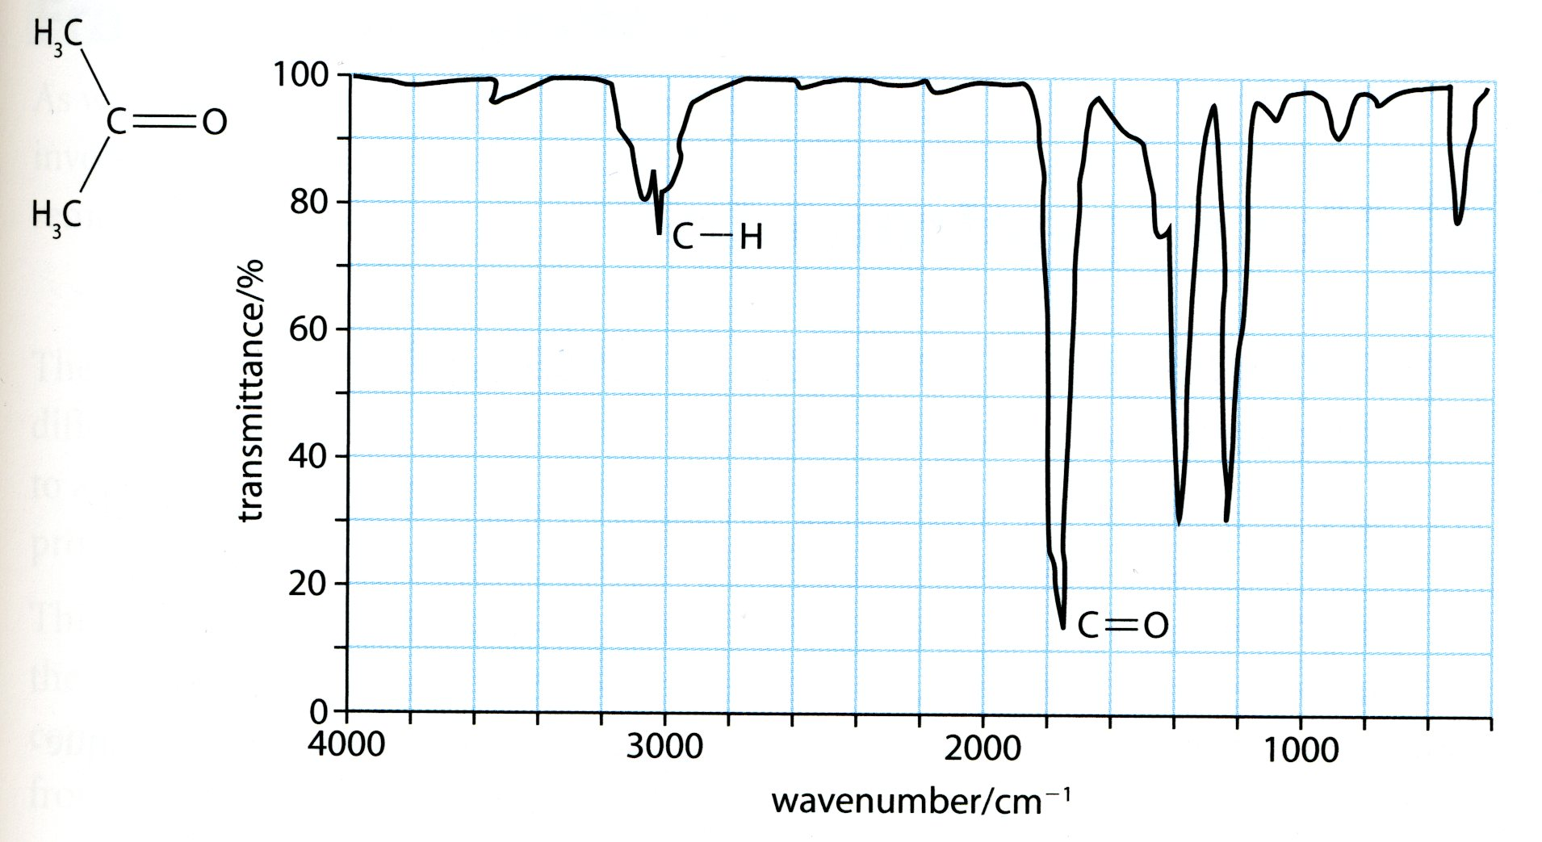
Consider the structure of propanone shown below. The base line at the top corresponds to 100 % transmittance and the key features are the troughs which occur at the natural frequencies of the bonds present in the molecule.

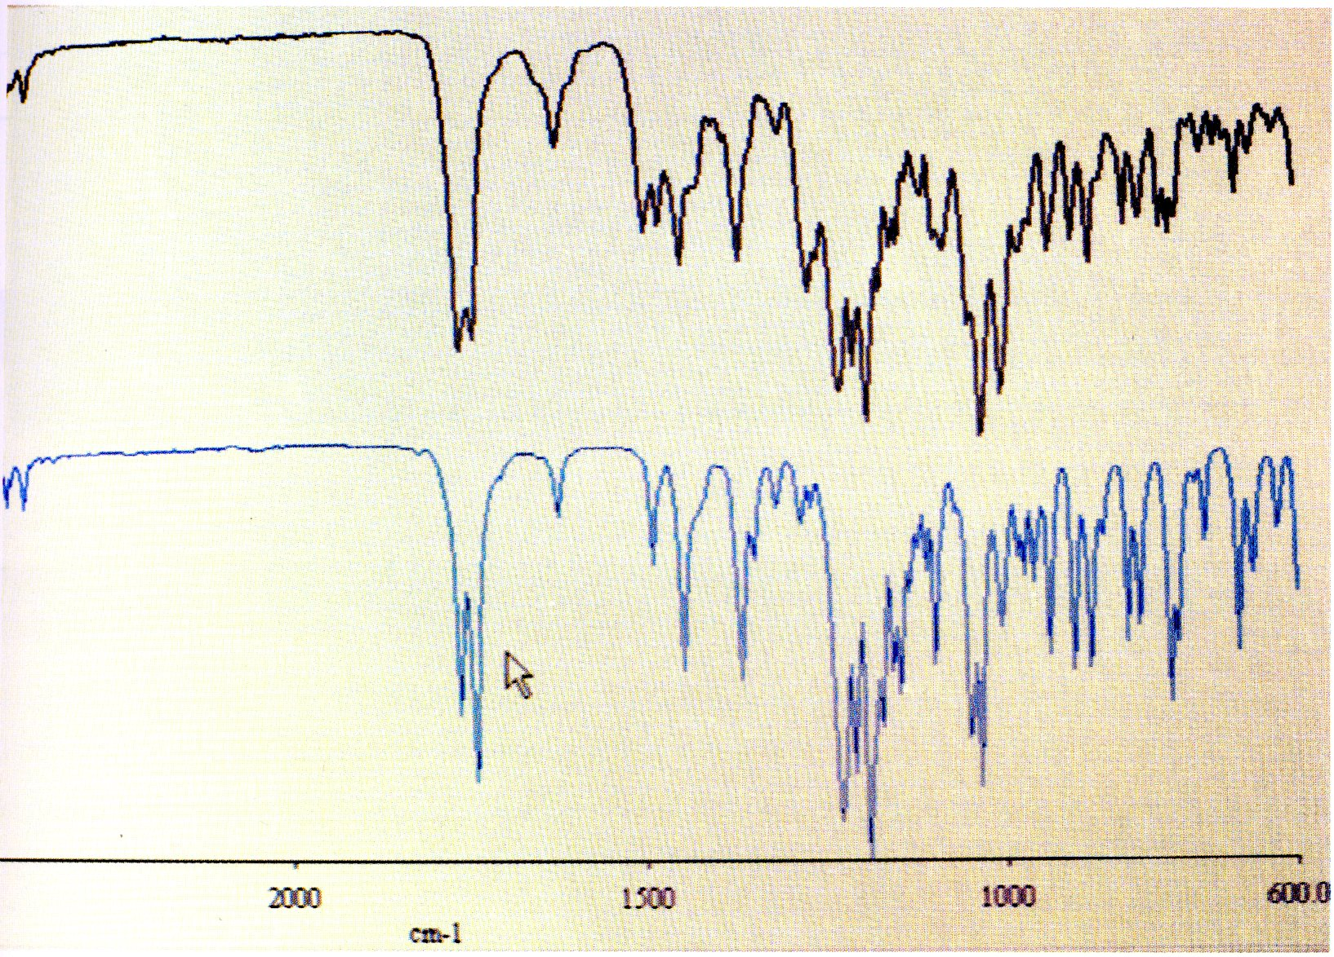
IR spectrum of the illegal drug heroin (blue) compared to that of an unknown sample (black). The near perfect match indicates that the sample contains a high percentage of heroin. Spectral analysis such as this can identify unknown compounds in mixtures or from samples taken from clothing or equipment. The technique is widely used in forensic science.

All the documents: tables and spectra come from the student school book:
Chemistry by Catrin Brown and Mike Ford

Worked examples:

