
Energy transfers
Watch the animation on the site « The animals save the planet » (http://www.animalssavetheplanet.com).

Comprehension :
Translate into French: The animals save the planet:

Choose the right words:

This picture takes place in an igloo/an isba /a casa.
The bear/beer/bier is sitting on a sofa while the penguin is walking/running/pedalling.
When the penguin speeds up/slows down, the light reduces.
When the penguin speeds up/slows down, the light increases.
When the bear gives the penguin a fish/ a slap/ a sweet it pedals more/less.
The bigger the fish is, the less/the more the penguin pedals.
With the first bulb (lamp), the penguin needs to pedal more/less to obtain the same lighting.
The second bulb (lamp) needs less/more energy to light up.

Physics

1)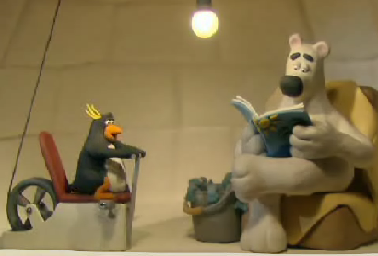For each of these energies, say if the penguin uses it or produces it.
Chemical energy:
Mechanical energy (furnished by the muscles):
Thermal energy:

2) What is happening when the penguin pedals ?
Use the words: alternator, convert, energy, fish, mechanical, electrical, energy

3) Put the right word at the right place and find the sentence you eared :
Energy, bulbs, fifth, energy, ordinary, use, of the, one, bulbs, of, saving

Convert one fifth in percent.(make a sentence)

4) Here is the graph of the conversion of energy in a lamp :

Lighting energy
Electrical energy

Thermal energy
lamp

Use the same graph to schematize the conversion of energy in the penguin:

penguin

Partie française :

Traduis en français la phrase de conclusion du dessin animé :

Comment s’appelle l’objet derrière le manchot ?

Décris les transformations énergétiques du poisson à l’ampoule par des schémas. Cite tous les types d’énergie transférés ou convertis :

